Gavin’s story:
He finds an old booklet / electronics kit at Reba’s. She says she just got that at an estate sale. Marvin’s estate.
The booklet sends him on an adventure through town, requiring him to do electronics. It looks like an old scavenger hunt game that was never finished. He and his friends find it fun. But it starts getting weird, with notes that “this is for real,” and “keep this a secret,” and lots of stuff that makes it seem like it might be for real at the end.
The challenges go from electronics to robotics, and Gavin has to build a robot that can do more and more complicated tasks with increasing precision. By the end, he has a list of very specific things he must do on the last task, and has built a robot that does all kinds of stuff.

The beginning of Marvin’s story:
When he’s young, he and his friend Evie find a meteorite in the mountains, surrounded by sunflowers. Touching it has a wild effect on him, and he’s about to build something crazy to bring on the aliens, but eating sunflower seeds that Evie has harvested slows him down, and eventually Evie gives him a tincture she made from the petals and it breaks the connection with the stone, but leaves him with weird dreams of a man without a face standing in a field of sunflowers.
As he grows older, the whole thing feels like a fever dream. They’re convinced he got maybe some radiation sickness but they don’t tell anyone anything. But now Marvin has all kinds of big ideas about the universe and wormholes and spacetime, and even makes an invention that he sells to Tanthrop Hammond.

Marvin’s Invention
Marvin’s invention, the Harmonic Vibration Nullifier, is a compact device that cancels unwanted mechanical vibrations by emitting precisely tuned counter-resonant waves. Inspired by insights he received from touching an entangled alien meteorite, the device unknowingly taps into a deeper resonance principle that connects across space and time. Though marketed as a breakthrough in stabilization technology, its true significance lies in its ability to synchronize with an entangled partner—laying the foundation for wormhole activation through harmonic alignment. Marvin sells the patent, becomes wealthy, and uses the funds to quietly rebuild Brimley Forge while secretly continuing his work on the larger cosmic mystery.

The circuits
Marvin starts the game as something for kids and wants to do simple electronics. He’s got this sense that it’s important for a kid to learn how to make flashing circuits and a robot. He can see this future where robots need to go through the wormholes, go where humans can’t. It’s just a memory now. The sunflower tincture saved him. He isn’t even fully conscious of why he feels this way…he can just sort of see it in his mind. He wants humans to develop this tech to stay ahead of aliens, but he can’t get everything totally right so he can’t publish. It’s just the resonance nullifier that he’s got going. He sees sunflowers growing in a pattern outside Tanthrop Hammond and he starts to wonder. He goes back to the spot. There is a crater, but the foliage has changed, and the meteorite is gone.
So Marvin is creating this game right from the beginning, thinking about teaching sequences and resonance and robots.

The Robots
Marvin is completely obsessed with the idea of turning the old underground into a robotics course. He loves microcontrollers and all the possibilities and he’s having a ball making robots that can do things underground and he sees that as great “training” for some day when robots will have to go through wormholes and he wants young people playing with this idea in hopes that a couple really smart ones get inspired, so now he’s making even more of the course.

The Coding
The machine requires someone to put code on a microcontroller that can “resonate.”
The code should output Fibonacci numbers as blinks to “activate,” then it should input Fibonacci numbers and output their position in the sequence. It should output in interesting ways.

Marvin’s story, cont’d
Marvin is making this game. He’s rich. He’s an eccentric about town. He lives alone in the mansion. He sees sunflowers growing in a spiral and traces it back to the Tanthrop Hammond plant. He cajoles his way in and discovers what they’re doing. Unable to help himself, he touches the stone, which is now much more refined and powerful.
But he’s still got antibodies, so that night, asleep, he has a face-off with the man, and he learns the entire plan. He is the man at one point and can see the plan. Full reveal of the alien plan. Big life-changing event.
When the radio waves come through, it will open a portal and the aliens will arrive.
Marvin needs to already have been working on exotic matter at this point, not at Tanthrop Hammond, but alone, at his house.

🧬 What Is Exotic Matter in Your Story?

Exotic Matter = Resonant Condensate formed under time-synchronized electromagnetic fields.

In Marvin’s case, it’s not an element—it’s a state of matter that only exists:
- Under precise resonant vibration conditions,
- In the presence of entangled spacetime fields,
- And only when the timing and location are right (like a planetary alignment… or Fibonacci-sequenced pulses).

✅ Traits of Your Exotic Matter:
- Mass appears to oscillate between positive and negative values (not truly “massless,” but unstable).
- Generates a gravity-canceling effect in localized fields.
- Reacts to resonance and Fibonacci sequences, almost as if it “remembers” the pattern that created it.
- Appears silvery but translucent, floating slightly off surfaces, as if rejecting the pull of gravity.

⚗️ How Does Marvin Make It?

Step 1:

Entangled Crystal Seed
- Marvin isolates a fragment from the meteorite—a crystal embedded in the stone.
- The crystal is entangled with something else across time (or elsewhere in the universe).

Step 2:

Constructs a Resonance Chamber
- A homemade device built from copper coils, piezoelectric disks, rotating magnets, and oscillating laser pulses.
- At its core is a spherical vacuum chamber with a quartz base, where the crystal is suspended on magnetic fields.

Step 3:

Generates a Fibonacci Pulse Pattern
- Marvin runs an algorithm that uses Fibonacci time intervals to send current through the coils.
- As the chamber hums, it builds resonance—not sound, but spacetime vibration.

“Once entangled, resonance can synchronize them.”

Step 4:

Field Collapse
- At the peak of resonance, the crystal “winks”—and a droplet of exotic matter condenses at the chamber’s center.
- It’s unstable. Marvin captures it in a magnetically suspended container, where it lasts only minutes unless cooled with a liquid helium substitute he invented from sunflower-petal compounds.

🌌 Sci-Fi Hook: Exotic Matter Is a Bridge

The exotic matter:
- Opens a small time-folding rift—not large enough to send a person, but just big enough for a robot.
- Acts as a key, a fuel, and a lock all at once.
- Responds to specific resonance codes—only Gavin’s robot, programmed with the correct blinking/Fibonacci sequence, can activate it safely.

What’s it made of?
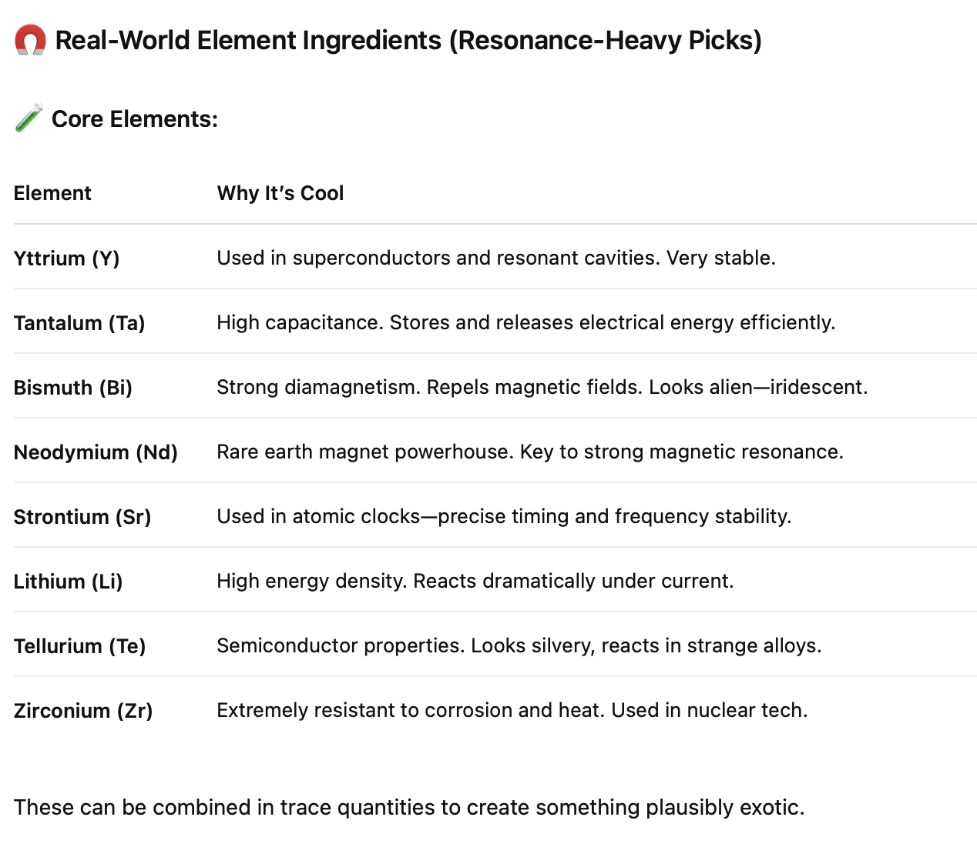

🔮 Invented Material:

Nyxellium

Nyxellium (pronounced: NIX-ell-ee-um)
Named after Nyx, the Greek goddess of the night—symbolizing the unknown and the veil between worlds.

In-universe description:

A crystalline compound formed under Fibonacci-timed electromagnetic pulses in the presence of an entangled meteorite core. It only exists briefly in a vacuum field tuned to harmonize with the crystal’s resonant frequency.

Composition (fictional alloy):

Nyxellium-7:
- 33% Yttrium
- 22% Neodymium
- 18% Bismuth
- 11% Strontium
- 8% Tantalum
- 5% Lithium
- 3% Tellurium
- trace amounts of alien-organic silicate, derived from the meteorite’s lattice

🧠 The trace compound is the key—it’s not from Earth, and it’s what makes the matter entangle and resonate.

🧬 How Marvin Describes It in His Notes

“I didn’t make Nyxellium. I set the chamber humming, played the sequence, and it grew—like a crystal forming in midair, only sideways through time.”

“The key isn’t the heat. It’s the rhythm. These elements don’t bond unless the waveform is singing the right tune.”

🧰 What It Looks Like
- Shimmers like polished bismuth, but semi-transparent.
- Light pulses through it in Fibonacci spirals.
- Cold to the touch, but causes static discharge when near electronics.
- Hums faintly when the right frequency is nearby—like it’s listening.

⚙️ Classroom Tie-In (STEM Moment)

You could build a real-life simulation:
- Use a piezo speaker + LED.
- Program Arduino to pulse Fibonacci blinks and sound waves.
- Teach resonance and material properties, leading to a “simulated” Nyxellium growth moment.

So here’s the story: Marvin is working on this material, and realizes that he needs material from the meteorite. He realizes some of it is in his blood and tries to harvest it from there. But there isn’t enough. So he goes looking for it. Learns about how the sunflowers developed defenses to it. This becomes part of his life project. Thinks that the game is just to figure out what the aliens were using and recreate it here. Maybe this research is what leads to the discovery of the materials. But there’s a sense that some kind of nanotech is involved, something that controls things at the molecular level.
And then he sees the sunflowers, goes to Tanthrop Hammond, isn’t allowed to look at their project, but sends a robot down the ventilation for a late-night break-in. The robot is remote controlled and uses EMI bursts or other RF device to break in. Possibly rewrite so it’s not Tanthrop Hammond, but Marvin’s old company that he got pushed out of. He goes in, finds the stone, touches it, and all hell breaks loose.

Once entangled, resonance can synchronize them

